8.83: a) In terms of the primed coordinates,

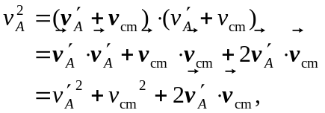

with a similar expression for 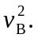 The total kinetic energy is then
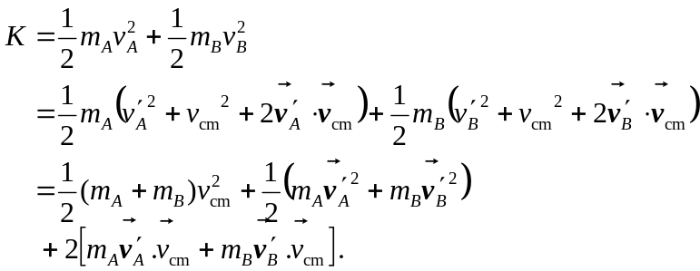

The last term in brackets can be expressed as
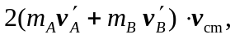
and the term
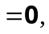

and so the term in square brackets in the expression for the kinetic energy vanishes, showing the desired result. b) In any collision for which other forces may be neglected the velocity of the center of mass does not change, and the 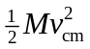 in the kinetic energy will not change. The other terms can be zero (for a perfectly inelastic collision, which is not likely), but never negative, so the minimum possible kinetic energy is 